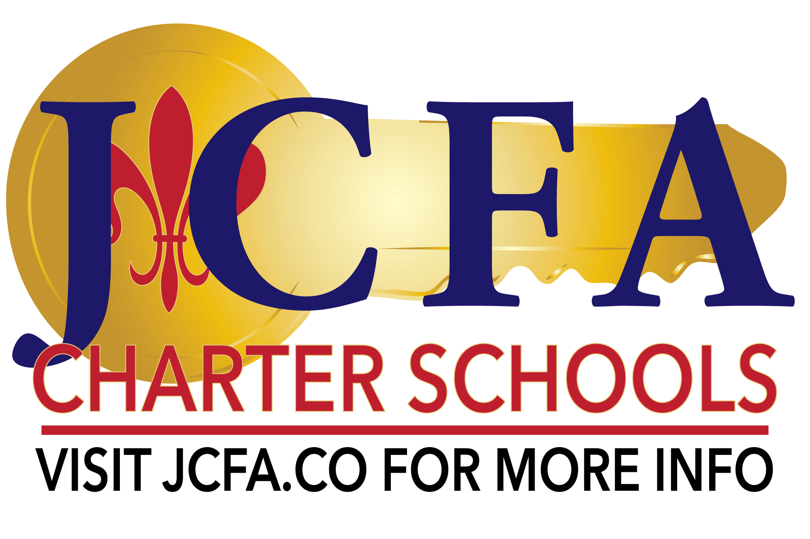

Board of Governance Regular Meeting Agenda

September 17, 2024

JCFA East

5:00PM

Watch live: <https://www.youtube.com/channel/UC-0gdE93HAKBMIYXML9c6iw>

* Welcome by Board Chair, Leslie Leavoy
  + Executive Committee: Vice Chair Mina Hogan, Treasurer Nick LaCour, Secretary Jeremy Davis
  + Members: Tara Clement, Kelly Lulich, Nikki Ummel, Candace Washington, Derek Wiltz, Landry Young,
  + Documentation of attendance: Tara Clement, Mina Hogan, Nick LaCour, Leslie Levoy, Kelly Lulich, Candace Washington, Landry Young
  + Called to order at 5:21 PM
  + Board Chair reviewed upcoming events & deadline including Ethics Training & 1st Annual Gala
* Finance Committee Report
  + Consideration for Approval 2024/2025 Legislative Differentiated Stipend Allocations
    - W1D, 026123, and W1A
    - Public Comment
    - Motion to approve the 2024-2025 Legislative Differentiated Stipend Allocations: Kelly Lulich
      * Second: Candace Washington
      * Public Comment - none
      * Motion passed by unanimous vote
  + AFR update: 026123 submitted 9/15 and W1A and W1D in process, due 9/30/24
* 2024-2025 Pupil Progression Plan
  + W1A, W1D and 026123
  + Public Comment
  + Motion to approve the 2024-2025 Pupil Progression Plans for W1A, W1D, & 026123 with updates: Candace Washington
    - Second: Landry Young
    - Public Comment - none
    - Motion passed by unanimous vote
* Consideration of Approval: 2024-2025 Student Handbook revisions
  + [Draft 24.25_JCFAOrg__StudentParentHandbook.docx](https://docs.google.com/document/d/1pNISzq7L7Nue2X8kSlzom-OWFklyHOzF/edit?usp=sharing&ouid=102022481925054200662&rtpof=true&sd=true)
  + Public Comment
  + Motion to approve the 2024-2025 Student Parent Handbook revisions with the stipulation a final copy will be shared with the Board: Kelly Lulich
    - Second: Candace Washington
    - Public Comment - none
    - Motion passed by unanimous vote
* Motion to amend the agenda to approve the minutes from the 2024 Board retreat: Mina Hogan
  + Second: Tara Clement
  + Public Comment - none
  + Motion passed by unanimous vote
* Motion to approve the minutes, waiving the reading of minutes, for the 2024 Board retreat: Kelly Lulich
  + Second: Nick Lacour
  + Public Comment - none
  + Motion passed by unanimous vote
* Executive Director Report
  + Student Counts
  + 2024-2025 Goals
  + Act 641 Reporting for W1A, W1D and 026
* Motion to adjourn: Nick LaCour
  + Second: Kelly Lulich
  + Motion passed by unanimous vote
  + Adjourn at 6:38PM

2024 BOG Retreat

9AM: Arrivals, refreshments, get settled

* Welcome by Chair
  + Documentation of attendance: Tara Clement, Mina Hogan, Nick LaCour, Leslie Leavoy, Kelly Lulich, Derek Wiltz, Landry Young
  + Called to order at 9:19AM
* Approval of the FY 2023-2024 [Compliance Questionnaire](https://docs.google.com/document/d/188Sbg8vUo4EZHtjoLB-PT-CPI7bnQo9k/edit?usp=drive_link&ouid=102022481925054200662&rtpof=true&sd=true) for audit
  + Executive Director presented items for questionnaire
  + Motion to allow the Finance Committee to review the final document to submit to the auditors on behalf of the Board: Kelly Lulich
    - Second: Landry Young
    - Public Comment - none
    - Motion passed by unanimous vote
* Consideration of committee appointments
  + Finance (must meet monthly)
    - Chair: Nick LaCour
    - Members: Leslie Levoy & Mina
  + Academics (meet as needed)
    - Chair: Kelly Lulich
    - Members: Derek Wiltz & Jeremy Davis
  + Oversight (meet as needed)
    - Chair: Mina Hogan
    - Members: Nick LaCour, Leslie Levoy, & Jeremy Davis
  + HR Policy (meet as needed)
    - Chair: Tara Clement
    - Members: Landry Young, Nikki Ummel, & Candace Washington
* Review of [fund balance policy](https://drive.google.com/file/d/1om9L9ijt9DejRy3S1wTvGKxp9u4_452Y/view?usp=drive_link) for potential updates
  + Executive Director reviewed current policy & recommended updates
* Review Act 641 Reporting Requirements
  + Executive Director reviewed the reporting requirements
* Review of [legislation](https://drive.google.com/drive/folders/1Qp4Ys3_ZyIfa0FASr1isLHIG8fISSdWi?usp=drive_link) impacting schools
  + Executive Director reviewed various pieces of legislation & how they may impact or be implemented at JCFA
* Consideration of updates to pronoun use in handbooks
  + Motion to allow the update of the pronoun usage in handbooks to add “they” and “them”: Tara Clement
    - Second: Kelly Lulich
    - Public Comment - none
    - Motion passed by unanimous vote
* Update on NSBR funding and Baton Rouge campus location
  + Executive Director provided updates on the process of having the new campus location approved & the opening process
* Executive Director’s report academic data for 2023-2024
* Motion to adjourn: Mina Hogan
  + Second: Derek Wiltz
  + Motion passed by unanimous vote
  + Adjourn at 10:37AM

9:45-9:55 FAB

9:55

* Curriculum engagement for BOG members

10:30

* Board Development Training with [Kevin Guitterrez](mailto:kevin.guitterrez@discoveryhsf.org)

11:30

* Great Works Gala
* Board forecasting/long range goals
* Vision for future success

Noon

* Adjournment

Live Stream:<https://www.youtube.com/channel/UC-0gdE93HAKBMIYXML9c6iw>