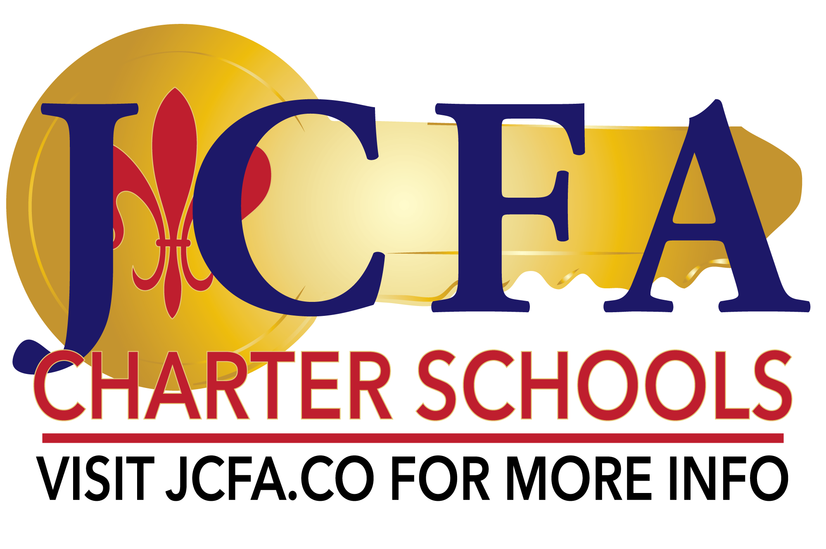

Board of Governance
JCFA East, 3410 Jefferson Highway, Jefferson LA 70121
Watch live: https://www.youtube.com/channel/UC-0gdE93HAKBMIYXML9c6iw
September 16, 2025

- Welcome by Board Chair
- Roll Call of BOG Members
- Approval of BOG Meeting Minutes from the Board Retreat
  - Public Comment
- Consideration of Signature Authority for 2025-2026 academic year
  - Public Comment
  - Executive Director, BOG Chair, Secretary and Treasurer
- Consideration of the 2025/2026 Pupil Progression Plans
  - Public Comment
  - W1A
  - W1D
  - 026123
- Consideration of the 2025/2026 Legislative Certificated/Non-Certificated Stipend Plan
  - Public Comment
- Consideration of the 2025/2026 Legislative Differentiated Stipend Plan
  - Public Comment
- Finance Update
  - including AFR/audit updates
  - current enrollment numbers and projections
- Committee Assignments
- Executive Director's Report

2025 Board Retreat
JCFA East, 3410 Jefferson Highway, Jefferson LA 70121
August 9, 2025
9:00AM

Watch live: https://www.youtube.com/channel/UC-0gdE93HAKBMIYXML9c6iw

- Welcome by Board Chair, Leslie Leavoy
- Roll call of BOG Members
  - Executive Committee: Chair, Leslie Leavoy, Vice Chair Mina Hogan, Treasurer Nick LaCour, Secretary Jeremy Davis
  - Members: Tara Clement, Kelly Lulich, Candace Washington, Derek Wiltz, Landry Young
  - Documentation of attendance: Tara Clement, Jeremy Davis, Mina Hogan, Nick LaCour, Leslie Leavoy, Kelly Lulich, Candace Washington, Derek Wiltz, Landry Young
  - Call to order: 9:07am
- Board Training and Development presented by Melissa Carolloof LAPCS
- Review of BOG expectations and commitments
- Break
- Executive Session-Human Resources
  - Public Comment
  - Motion to move into Executive Session: Nick LaCour
    - Second: Candace Washington
    - Public Comment - none
    - Motion passed by unanimous vote
  - Motion to return from Executive Session: Jeremy Davis
    - Second: Landry Young
    - Public Comment - none
    - Motion passed by unanimous vote
- Executive Director’s Report
- Consideration for approval the meeting minutes from the July 15, 2025 special and regularly scheduled meetings
  - Public Comment
  - Motion to approve the July 2025 Special Meeting & Meeting minutes, waiving the reading of minutes: Nick LaCour
    - Second: Candace Washington
    - Public Comment - none
    - Motion passed by unanimous vote
- Consideration of the 25/27 Executive Committee: Secretary, Treasurer, Vice Chair and Chair
  - Nominations for Secretary
    - Nominations: Leslie Leavoy
    - Unanimous vote
  - Nominations for Treasurer
    - Elected for 2-year term in 24/25
    - Nick LaCour continues in position
  - Nominations for Vice Chair
    - Elected for 2-year term in 24/25
    - Mina Hogan continues in position
  - Nominations for Chair
    - Nominations: Jeremy Davis
    - Unanimous vote
  - Public comment on nominees
- Consideration of the 24/25 audit questionnaire
  - Motion to approve the 24/25 audit questionnaire as presented: Kelly Lulich
    - Second: Nick LaCour
    - Public Comment - none
    - Motion passed by unanimous vote
- Announcements and Other Board Business
- Adjournment
  - Motion to adjourn: Nick LaCour
    - Second: Kelly Lulich
    - Public Comment - none
    - Motion passed by unanimous vote
    - Adjourn at 12:09PM

